Operative Vaginal Birth

Indications for Operative Vaginal Delivery
- Prolonged second stage of labor
- Suspicion of immediate or potential fetal compromise
- Shortening of the second stage of labor for maternal benefit

Introduction and History
This article reviews the clinical use of vacuum extractor (VE) delivery instruments in modern obstetric management. The limitations and risks of the VE are considered, as is the choice of delivery technique (VE vs forceps vs cesarean delivery) when labor ceases or other complications ensue.
Both forceps and the VE are in use as delivery instruments. In recent decades, the VE has progressively replaced forceps as the instrument of choice for many practitioners. ^{[1, 2]} In the United States, more than 80% of operative vaginal deliveries involve vacuum extraction. ^{[3]} Active controversy concerns if and when operative vaginal deliveries should be conducted and which instrument is the best to use in specific clinical settings.
VE has a long history. The initial applications of vacuum techniques in deliveries began in the 18th century. While VE became widely popular in Europe, the technique was little used in the United States until after the early 1980s, following the introduction of a series of new instruments, including disposable soft-cup extractors, new rigid cup designs, and handheld vacuum pumps.
Despite the current popularity of VE, forceps are the instrument of choice for many older clinicians. This is because of medical conservatism and original training, higher success rates, and a presumption of improved speed and control of the birth process. Nonetheless, VE has gained popularity as it is seemingly easy to use, requires less anesthesia/analgesia, has lower maternal morbidity, and is commonly believed to be safe. Large differences are observed in the popularity of instrumental delivery and of the specific type of instrument used in varying parts of the United States. This reflects the biases introduced by original training, the inherent conservatism of practitioners in embracing different techniques, and the absence of fixed guidelines for instrumentation. ^{[4]}
The retirement of classically trained obstetricians, the inability to conduct training operations (which is now partially offset by new training models), the medical-legal climate, and other changes in practice (including the high incidence of cesarean deliveries) result in an unclear future for all types of instrumental delivery, including VE. Finding clear answers to important management questions concerning instrumental delivery remains elusive. A great deal of traditional lore concerning delivery practices remains. Objective analysis of what constitutes best practice by the newer methods of evidence-based medicine is limited by continuous changes in practice, small patient numbers in many studies, changes in the official definition of procedures, and, especially for VE, the introduction of new instruments.
Despite these limitations, a need still remains for safe and effective operative vaginal delivery options. Further, good data suggest that this help can be safely and expeditiously provided by an instrumental delivery using either the forceps or a VE instrument. ^{[5, 6, 7]}
For related information, see Medscape's Pregnancy Resource Center.

Prerequisites for Vacuum Extraction
Both forceps and vacuum extraction have the same general indications. Operator experience and skill generally are the factors that influence which instrument is chosen.

Informed consent
Informed consent is required for any surgical procedure, including an instrumental delivery.
Consent for an instrumental delivery, especially in the face of urgency, has always been problematic and is often incomplete. ^{[8]} This has always been a curious feature of obstetric management, as the potential for maternal or fetal injury in VE or forceps operations is always present. Further, the medical and legal risks from an assisted delivery are substantially greater than those associated with many other surgical procedures.
Routinely discussing possible obstetric interventions with families at an earlier time during the pregnancy as part of routine prenatal care is important because of the controversy concerning bedside consents in acute situations. When antepartum discussions have occurred and the need for an instrumental delivery procedure occurs during labor, misunderstandings are reduced.
In general, consent for a surgical procedure requires the following:
- An explanation of the need for the operation
- A discussion of risks and benefits
- A presentation of alternative modes of treatment
- An opportunity to ask questions
An emergent or abbreviated bedside consent process still requires the following:
- A (brief) description of the proposed operation to mother and family
- Review of the indications for the proposed procedure
- An indication of the limits of effort intended

Prepared physician
The clinician must have knowledge of the instrument chosen, VE indications, and well-practiced, appropriate technique. The decision to perform instrumentation should follow a logical progression involving an analysis of the course in labor, a pelvic examination with determination of fetal position and station, and a careful consideration of the fetal/pelvic relationship. In the uncommon situation that a true trial of instrumental delivery is contemplated, the obstetric team must understand the plan of management, the limits of intended effort, and the possibility of failure and the need for cesarean delivery.

Prepared patient
The initial requirement is always informed consent. Once consented, requirements include rupture of membranes, an engaged head, a fully dilated cervix and an empty bladder.
If the fetal position or the station of the presenting part is uncertain, a transperineal or transvaginal real time ultrasonographic examination is performed before attempting the operation. ^{[9]} Ultrasonography can also be used to judge the appropriateness of the vacuum cup application. ^{[10, 11]} These procedures are easily performed at the bedside. Position is readily identified by observing the fetal orbits and identifying characteristic intracranial anatomy (falx, posterior fossa, etc) and the location of the fetal spine.

Acceptable analgesia/anesthesia
Some outlet operative VE deliveries can be conducted without anesthesia or analgesia in multiparous patients. However, parturients do find operative vaginal procedures uncomfortable. Regional anesthesia may provide a more comfortable procedure.

Indications for Vacuum Extraction

General comments
The appropriate indications for operative delivery are those described by the American College of Obstetricians and Gynecologists (ACOG) in a practice bulletin. ^{[7]} Use of a vacuum is reasonable when an indication is present and can be readily and safely done; otherwise, cesarean delivery is the better option. The indications — as stated in the ACOG practice bulletin — for operative vaginal delivery are as follows:
- Protracted second stage of labor
- Suspicion of immediate or potential fetal compromise
- Shortening the second stage for maternal benefit
It should be noted that these indications are relative; no absolute indications exist. Also, cesarean delivery is an option in the same clinical setting.

Prolonged second stage of labor
An extended second stage of labor is a relative, but not absolute, indication for an instrumental delivery. From a review of the available data, an appropriate conclusion is that the longer the second stage, the lower the probability of spontaneous vaginal delivery, and the higher the risk of instrumentation or cesarean delivery. ^{[12, 13, 14, 15]}
For nulliparous women, a protracted second stage can be defined as no progress (descent, rotation) after about four hours with epidural anesthesia and about three hours without epidural anesthesia. ^{[12]} For multiparous women, a protracted second stage can be defined as no progress (descent, rotation) after about two hours with epidural anesthesia and about one hour without epidural anesthesia.
Not surprisingly, obstetrical trauma such as postpartum hemorrhage, chorioamnionitis, and perineal injury become more likely as the second stage is extended. The situation for the neonate is less clear, but some increase in overall morbidity is probable. The data suggest that the magnitude of the maternal risk is greater than that for the infant, assuming proper maternal and fetal monitoring.
Continued poor progress in labor is not to be ignored. Failure to progress is the most common indication for intervention by a cesarean or an instrumental delivery.
For patients with slow progress approaching these limits, a normal fetal heart tracing, and no other indication for expediting delivery, evaluation of the risk of operative delivery versus expectant management should be undertaken. If fetal descent is progressing, or other favorable changes have occurred, expectant management, encouragement and oxytocin are employed. If the patient is unable to continue or is exhausted and judged to be a good candidate for operative delivery, then this is a reasonable option. Recent studies have challenged an arbitrary end point to the second stage of labor. The ability of electronic fetal heart monitoring to assist in assessing fetal status makes shortening the second stage at a set point unwarranted. ^{[16]}

Suspicion of immediate or potential fetal compromise
The suspicion of immediate or potential fetal compromise (eg, abruption, acutely nonreassuring electronic fetal monitoring tracing) is a classic indication for either an operative or a cesarean delivery.
When prompt delivery is necessary, the station and position of the fetal head, the fetopelvic relationship, operator skill, and a judgment of the severity of risk dictate the mode of delivery. In most cases, cord prolapse, abruptio placentae, or persistent bradycardia at a high station, even with full dilation with an engaged head are best managed by a cesarean delivery. Evaluation must be undertaken to assess if vaginal delivery can be safely and readily achieved before proceeding.

Maternal medical disorders
Certain maternal disorders preclude the ability of the mother to perform Valsalva safely. Typically, cardiac, cerebrovascular, or pulmonary disorders are included. There are other maternal disorders (neuromuscular, spinal cord injury, etc) that make pushing ineffective. An operative vaginal delivery can be undertaken when uterine contractions/labor leads to a descended fetus to a station where the practitioner feels operative vaginal delivery can safely and effectively be done.

Contraindications to Vacuum Extraction
Vacuum operations are contraindicated in certain settings. Neither the vacuum not the forceps should be applied where the fetal risk is either unknown or perceived to be high, or when the application proves difficult or the maternal pelvic anatomy is questionable. Questions of operator skill and experience in that specific clinical setting are also noted.
General contraindications include the following:
- Operator inexperience
- Inability to achieve a correct application (midline, over flexion point)
- An inadequate trial of labor or lack of a standard indication
- Uncertainty concerning fetal position or station not resolved by examination or real-time ultrasound study
- Suspicion of fetopelvic disproportion (advanced cranial molding, bone overlap, caput)
- An inappropriate fetal presentation (eg, breech, face, brow)
- A known or suspected fetal bleeding diathesis or demineralizing bone disease
Relative contraindications are as follows:
- Prior scalp sampling
- Prior failed forceps
- Gestational diabetes or pregestational diabetes
- Known or suspected fetal macrosomia
The ACOG practice bulletin discourages the use of vacuum extraction prior to 34 weeks of gestation; however, it does not establish a safe lower limit for gestational age.

Comparison of instruments
Soft or flexible vacuum cups have a higher incidence of failure than either rigid vacuum cups (plastic or metal) or forceps. ^{[19]} This is primarily due to their higher frequency of spontaneous detachment pop-offs. However, the application of soft vacuum cups also results in less fetal cosmetic injury (principally scalp injury) than rigid cups. This partially reflects the inability of soft cups to generate the same degree of scalp traction as is possible when rigid cups are applied.

Other design issues are important to cup choice. In some plastic extractor designs, the relatively rigid tube connecting the handle to the cup precludes accurate placement of the instrument when the fetal head is markedly deflexed or occiput posterior. This contributes to failure when such cranial malpositions are present. Higher success rates have recently been reported when rigid plastic cups similar to the original Malmström design are used for such deflexed and posterior presentations

Prerequisites for Operative Vaginal Birth
- Cervix fully dilated and retracted
- Membranes ruptured
- Engagement of the fetal head
- Position of the fetal head has been determined
- Fetal weight estimation performed
- Pelvis thought to be adequate for vaginal birth
- Adequate anesthesia
- Maternal bladder has been emptied
- Patient has agreed after being informed of the risks and benefits of the procedure
- Willingness to abandon trial of operative vaginal birth and back-up plan in place in case of failure to deliver

Informed consent
Informed consent is required for any surgical procedure, including an instrumental delivery.
Consent for an instrumental delivery, especially in the face of urgency, has always been problematic and is often incomplete. ^{[8]} This has always been a curious feature of obstetric management, as the potential for maternal or fetal injury in VE or forceps operations is always present. Further, the medical and legal risks from an assisted delivery are substantially greater than those associated with many other surgical procedures.
Routinely discussing possible obstetric interventions with families at an earlier time during the pregnancy as part of routine prenatal care is important because of the controversy concerning bedside consents in acute situations. When antepartum discussions have occurred and the need for an instrumental delivery procedure occurs during labor, misunderstandings are reduced.
In general, consent for a surgical procedure requires the following:
- An explanation of the need for the operation
- A discussion of risks and benefits
- A presentation of alternative modes of treatment
- An opportunity to ask questions

An emergent or abbreviated bedside consent process still requires the following:
- A (brief) description of the proposed operation to mother and family
- Review of the indications for the proposed procedure
- An indication of the limits of effort intended

For vacuum extraction, the cup should be placed 2 cm anterior to the posterior fontanelle and centered over the sagittal suture, ensuring that no maternal tissue is included.

Vacuum Extraction Technique
Appropriate technique is important when the vacuum extraction (VE) is used. ^{[20, 21, 22, 23]} The safety and success of vacuum-conducted extraction operations depend on the following:
- The accuracy of the initial cup application (ie, cup center over flexion or pivot-point)
- Case choice
- The traction technique, including degree of effort (number of tractions), vector of traction, method of applied force
- The fetal cranial position (including deflection) and fetal station at the time of application
- The cup design
- The fetopelvic relationship
If the prerequisites for VE operation are met, informed consent is obtained. Thereafter, the position, station, and attitude of the fetal head are verified by pelvic examination and an instrument is chosen. To correctly insert and position the cup, a specific protocol is followed. ^{[20, 21]}

Correct application
Once what is believed to be a proper cup application is established, sufficient vacuum (100-150 mm Hg) to fix the cup to the fetal head is applied. A check of the cup should then again be done to ensure no maternal tissue is present before higher pressure that is required for traction is employed.
The labia are separated and the cup is compressed to allow insertion into the vagina. In order to effectively assist a vaginal delivery, placement of the vacuum should be at the correct flexion point. This is done so that the flexion point is an imaginary spot over that midline of the sagittal suture, approximately 6 cm from the anterior fontanelle and 3 cm from the posterior fontanelle (see figure). The center of the cup is placed at the pivot point, making the edge of the cup ~3 cm from the anterior fontanelle and just at the edge of the posterior fontanelle.

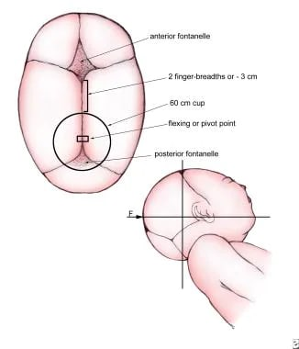
Cranial flexion or pivot point.

Vacuum Extraction Technique
Appropriate technique is important when the vacuum extraction (VE) is used. ^{[20, 21, 22, 23]} The safety and success of vacuum-conducted extraction operations depend on the following:
- The accuracy of the initial cup application (ie, cup center over flexion or pivot-point)
- Case choice
- The traction technique, including degree of effort (number of tractions), vector of traction, method of applied force
- The fetal cranial position (including deflection) and fetal station at the time of application
- The cup design
- The fetopelvic relationship

If the prerequisites for VE operation are met, informed consent is obtained. Thereafter, the position, station, and attitude of the fetal head are verified by pelvic examination and an instrument is chosen. To correctly insert and position the cup, a specific protocol is followed. ^{[20, 21]}

Correct application
Once what is believed to be a proper cup application is established, sufficient vacuum (100-150 mm Hg) to fix the cup to the fetal head is applied. A check of the cup should then again be done to ensure no maternal tissue is present before higher pressure that is required for traction is employed.
The labia are separated and the cup is compressed to allow insertion into the vagina. In order to effectively assist a vaginal delivery, placement of the vacuum should be at the correct flexion point. This is done so that the flexion point is an imaginary spot over that midline of the sagittal suture, approximately 6 cm from the anterior fontanelle and 3 cm from the posterior fontanelle (see figure). The center of the cup is placed at the pivot point, making the edge of the cup ~3 cm from the anterior fontanelle and just at the edge of the posterior fontanelle.

Access to the posterior fontanel is usually partially blocked once the extractor cup is correctly placed, rendering this familiar landmark unusable. The further the cup center is displaced from the cranial pivot or flexion point, the greater the failure rate. Traction with an oblique application results in progressive cranial deflexion or twisting (see the image below).

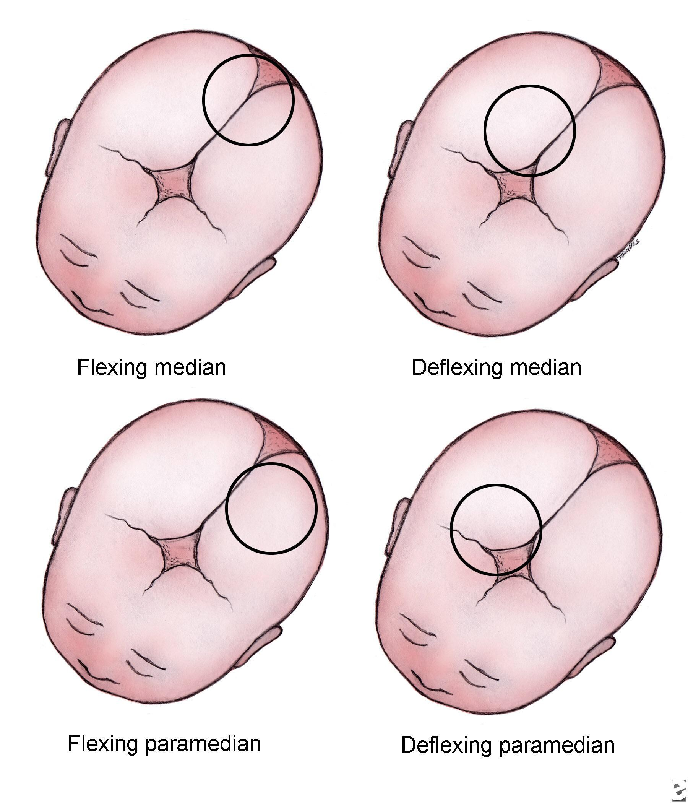

Introduction and History
This article reviews the clinical use of vacuum extractor (VE) delivery instruments in modern obstetric management. The limitations and risks of the VE are considered, as is the choice of delivery technique (VE vs forceps vs cesarean delivery) when labor ceases or other complications ensue.
Both forceps and the VE are in use as delivery instruments. In recent decades, the VE has progressively replaced forceps as the instrument of choice for many practitioners. ^{[1, 2]} In the United States, more than 80% of operative vaginal deliveries involve vacuum extraction. ^{[3]} Active controversy concerns if and when operative vaginal deliveries should be conducted and which instrument is the best to use in specific clinical settings.
VE has a long history. The initial applications of vacuum techniques in deliveries began in the 18th century. While VE became widely popular in Europe, the technique was little used in the United States until after the early 1980s, following the introduction of a series of new instruments, including disposable soft-cup extractors, new rigid cup designs, and handheld vacuum pumps.
Despite the current popularity of VE, forceps are the instrument of choice for many older clinicians. This is because of medical conservatism and original training, higher success rates, and a presumption of improved speed and control of the birth process. Nonetheless, VE has gained popularity as it is seemingly easy to use, requires less anesthesia/analgesia, has lower maternal morbidity, and is commonly believed to be safe. Large differences are observed in the popularity of instrumental delivery and of the specific type of instrument used in varying parts of the United States. This reflects the biases introduced by original training, the inherent conservatism of practitioners in embracing different techniques, and the absence of fixed guidelines for instrumentation. ^{[4]}
The retirement of classically trained obstetricians, the inability to conduct training operations (which is now partially offset by new training models), the medical-legal climate, and other changes in practice (including the high incidence of cesarean deliveries) result in an unclear future for all types of instrumental delivery, including VE. Finding clear answers to important management questions concerning instrumental delivery remains elusive. A great deal of traditional lore concerning delivery practices remains. Objective analysis of what constitutes best practice by the newer methods of evidence-based medicine is limited by continuous changes in practice, small patient numbers in many studies, changes in the official definition of procedures, and, especially for VE, the introduction of new instruments.
Despite these limitations, a need still remains for safe and effective operative vaginal delivery options. Further, good data suggest that this help can be safely and expeditiously provided by an instrumental delivery using either the forceps or a VE instrument. ^{[5, 6, 7]}
For related information, see Medscape's Pregnancy Resource Center.

Prerequisites for Vacuum Extraction
Both forceps and vacuum extraction have the same general indications. Operator experience and skill generally are the factors that influence which instrument is chosen.

Informed consent
Informed consent is required for any surgical procedure, including an instrumental delivery.
Consent for an instrumental delivery, especially in the face of urgency, has always been problematic and is often incomplete. ^{[8]} This has always been a curious feature of obstetric management, as the potential for maternal or fetal injury in VE or forceps operations is always present. Further, the medical and legal risks from an assisted delivery are substantially greater than those associated with many other surgical procedures.
Routinely discussing possible obstetric interventions with families at an earlier time during the pregnancy as part of routine prenatal care is important because of the controversy concerning bedside consents in acute situations. When antepartum discussions have occurred and the need for an instrumental delivery procedure occurs during labor, misunderstandings are reduced.
In general, consent for a surgical procedure requires the following:
- An explanation of the need for the operation
- A discussion of risks and benefits
- A presentation of alternative modes of treatment
- An opportunity to ask questions
An emergent or abbreviated bedside consent process still requires the following:
- A (brief) description of the proposed operation to mother and family
- Review of the indications for the proposed procedure
- An indication of the limits of effort intended

Prepared physician
The clinician must have knowledge of the instrument chosen, VE indications, and well-practiced, appropriate technique. The decision to perform instrumentation should follow a logical progression involving an analysis of the course in labor, a pelvic examination with determination of fetal position and station, and a careful consideration of the fetal/pelvic relationship. In the uncommon situation that a true trial of instrumental delivery is contemplated, the obstetric team must understand the plan of management, the limits of intended effort, and the possibility of failure and the need for cesarean delivery.

Prepared patient
The initial requirement is always informed consent. Once consented, requirements include rupture of membranes, an engaged head, a fully dilated cervix and an empty bladder.
If the fetal position or the station of the presenting part is uncertain, a transperineal or transvaginal real time ultrasonographic examination is performed before attempting the operation. ^{[9]} Ultrasonography can also be used to judge the appropriateness of the vacuum cup application. ^{[10, 11]} These procedures are easily performed at the bedside. Position is readily identified by observing the fetal orbits and identifying characteristic intracranial anatomy (falx, posterior fossa, etc) and the location of the fetal spine.

Acceptable analgesia/anesthesia
Some outlet operative VE deliveries can be conducted without anesthesia or analgesia in multiparous patients. However, parturients do find operative vaginal procedures uncomfortable. Regional anesthesia may provide a more comfortable procedure.

Indications for Vacuum Extraction

General comments
The appropriate indications for operative delivery are those described by the American College of Obstetricians and Gynecologists (ACOG) in a practice bulletin. ^{[7]} Use of a vacuum is reasonable when an indication is present and can be readily and safely done; otherwise, cesarean delivery is the better option. The indications — as stated in the ACOG practice bulletin — for operative vaginal delivery are as follows:
- Protracted second stage of labor
- Suspicion of immediate or potential fetal compromise
- Shortening the second stage for maternal benefit
It should be noted that these indications are relative; no absolute indications exist. Also, cesarean delivery is an option in the same clinical setting.

Prolonged second stage of labor
An extended second stage of labor is a relative, but not absolute, indication for an instrumental delivery. From a review of the available data, an appropriate conclusion is that the longer the second stage, the lower the probability of spontaneous vaginal delivery, and the higher the risk of instrumentation or cesarean delivery. ^{[12, 13, 14, 15]}
For nulliparous women, a protracted second stage can be defined as no progress (descent, rotation) after about four hours with epidural anesthesia and about three hours without epidural anesthesia. ^{[12]} For multiparous women, a protracted second stage can be defined as no progress (descent, rotation) after about two hours with epidural anesthesia and about one hour without epidural anesthesia.
Not surprisingly, obstetrical trauma such as postpartum hemorrhage, chorioamnionitis, and perineal injury become more likely as the second stage is extended. The situation for the neonate is less clear, but some increase in overall morbidity is probable. The data suggest that the magnitude of the maternal risk is greater than that for the infant, assuming proper maternal and fetal monitoring.
Continued poor progress in labor is not to be ignored. Failure to progress is the most common indication for intervention by a cesarean or an instrumental delivery.
For patients with slow progress approaching these limits, a normal fetal heart tracing, and no other indication for expediting delivery, evaluation of the risk of operative delivery versus expectant management should be undertaken. If fetal descent is progressing, or other favorable changes have occurred, expectant management, encouragement and oxytocin are employed. If the patient is unable to continue or is exhausted and judged to be a good candidate for operative delivery, then this is a reasonable option. Recent studies have challenged an arbitrary end point to the second stage of labor. The ability of electronic fetal heart monitoring to assist in assessing fetal status makes shortening the second stage at a set point unwarranted. ^{[16]}

Suspicion of immediate or potential fetal compromise
The suspicion of immediate or potential fetal compromise (eg, abruption, acutely nonreassuring electronic fetal monitoring tracing) is a classic indication for either an operative or a cesarean delivery.
When prompt delivery is necessary, the station and position of the fetal head, the fetopelvic relationship, operator skill, and a judgment of the severity of risk dictate the mode of delivery. In most cases, cord prolapse, abruptio placentae, or persistent bradycardia at a high station, even with full dilation with an engaged head are best managed by a cesarean delivery. Evaluation must be undertaken to assess if vaginal delivery can be safely and readily achieved before proceeding.

Maternal medical disorders
Certain maternal disorders preclude the ability of the mother to perform Valsalva safely. Typically, cardiac, cerebrovascular, or pulmonary disorders are included. There are other maternal disorders (neuromuscular, spinal cord injury, etc) that make pushing ineffective. An operative vaginal delivery can be undertaken when uterine contractions/labor leads to a descended fetus to a station where the practitioner feels operative vaginal delivery can safely and effectively be done.

Contraindications to Vacuum Extraction
Vacuum operations are contraindicated in certain settings. Neither the vacuum not the forceps should be applied where the fetal risk is either unknown or perceived to be high, or when the application proves difficult or the maternal pelvic anatomy is questionable. Questions of operator skill and experience in that specific clinical setting are also noted.
General contraindications include the following:
- Operator inexperience
- Inability to achieve a correct application (midline, over flexion point)
- An inadequate trial of labor or lack of a standard indication
- Uncertainty concerning fetal position or station not resolved by examination or real-time ultrasound study
- Suspicion of fetopelvic disproportion (advanced cranial molding, bone overlap, caput)
- An inappropriate fetal presentation (eg, breech, face, brow)
- A known or suspected fetal bleeding diathesis or demineralizing bone disease
Relative contraindications are as follows:
- Prior scalp sampling
- Prior failed forceps
- Gestational diabetes or pregestational diabetes
- Known or suspected fetal macrosomia
The ACOG practice bulletin discourages the use of vacuum extraction prior to 34 weeks of gestation; however, it does not establish a safe lower limit for gestational age. ^{[7]}

Definitions
ACOG has established standard definitions for instrumental delivery operations. These include outlet, low, and midpelvic operations. While the guidelines were originally written for forceps procedures, the same descriptions are easily applied to vacuum extraction operations with minor modifications. ^{[17, 7]}
Outlet forceps/vacuum
- The leading point of the fetal skull has reached the pelvic floor, and at or on the perineum, the scalp is visible at the introitus without separating the labia.
- The sagittal suture is in anteroposterior diameter or a right or left occiput anterior or posterior position.
- Rotation does not exceed 45 degrees.
Low forceps/vacuum
- The leading point of the fetal skull is ≥2 cm beyond the ischial spines, but not on the pelvic floor (ie, station is at least +2/5 cm).
- Low forceps have two subdivisions:
-Rotation ≤45 degrees
-Rotation >45 degrees
Midforceps/vacuum
- The head is engaged (ie, at least 0 station), but the leading point of the skull is not ≥2 cm beyond the ischial spines (ie, station is 0/5 cm or +1/5 cm).

Design of the Vacuum Extractor

Vacuum extraction instruments
Vacuum extraction (VE) instruments are constructed of varying materials including polyethylene or silastic plastic and stainless steel. Several features are found in all designs. These include the following:
- A mushroom-shaped vacuum cup of varying composition, diameter, and depth
- A fixed internal vacuum grid or guard within the vacuum cup
- A combined vacuum pump / handle or a vacuum port for a vacuum hose attachment
- A handle for traction
Rigid-cup designs include the classic Malmström stainless steel vacuum cup and the various modifications of this instrument introduced since the 1960s. New rigid plastic cup extractors mimic the Malmström device. These were originally designed for use with deflexed or posterior positioned heads but now are becoming popular for all types of deliveries. ^{[18]} A recent trend in VE design is to incorporate the vacuum pump within the handle, avoiding the need for a separate vacuum tube and for the assistance of a birth attendant in producing vacuum.
The soft-cup extractors include numerous disposable polyethylene or combined polyethylene-silastic cup designs that differ in largely inconsequential and clinically unimportant ways.

Comparison of instruments
Soft or flexible vacuum cups have a higher incidence of failure than either rigid vacuum cups (plastic or metal) or forceps. ^{[19]} This is primarily due to their higher frequency of spontaneous detachment pop-offs. However, the application of soft vacuum cups also results in less fetal cosmetic injury (principally scalp injury) than rigid cups. This partially reflects the inability of soft cups to generate the same degree of scalp traction as is possible when rigid cups are applied.
Other design issues are important to cup choice. In some plastic extractor designs, the relatively rigid tube connecting the handle to the cup precludes accurate placement of the instrument when the fetal head is markedly deflexed or occiput posterior. This contributes to failure when such cranial malpositions are present. Higher success rates have recently been reported when rigid plastic cups similar to the original Malmström design are used for such deflexed and posterior presentations

Vacuum Extraction Technique
Appropriate technique is important when the vacuum extraction (VE) is used. ^{[20, 21, 22, 23]} The safety and success of vacuum-conducted extraction operations depend on the following:
- The accuracy of the initial cup application (ie, cup center over flexion or pivot-point)
- Case choice
- The traction technique, including degree of effort (number of tractions), vector of traction, method of applied force
- The fetal cranial position (including deflection) and fetal station at the time of application
- The cup design
- The fetopelvic relationship
If the prerequisites for VE operation are met, informed consent is obtained. Thereafter, the position, station, and attitude of the fetal head are verified by pelvic examination and an instrument is chosen. To correctly insert and position the cup, a specific protocol is followed. ^{[20, 21]}

Correct application
Once what is believed to be a proper cup application is established, sufficient vacuum (100-150 mm Hg) to fix the cup to the fetal head is applied. A check of the cup should then again be done to ensure no maternal tissue is present before higher pressure that is required for traction is employed.
The labia are separated and the cup is compressed to allow insertion into the vagina. In order to effectively assist a vaginal delivery, placement of the vacuum should be at the correct flexion point. This is done so that the flexion point is an imaginary spot over that midline of the sagittal suture, approximately 6 cm from the anterior fontanelle and 3 cm from the posterior fontanelle (see figure). The center of the cup is placed at the pivot point, making the edge of the cup ~3 cm from the anterior fontanelle and just at the edge of the posterior fontanelle.

Cranial flexion or pivot point.
Access to the posterior fontanel is usually partially blocked once the extractor cup is correctly placed, rendering this familiar landmark unusable. The further the cup center is displaced from the cranial pivot or flexion point, the greater the failure rate. Traction with an oblique application results in progressive cranial deflexion or twisting (see the image below).
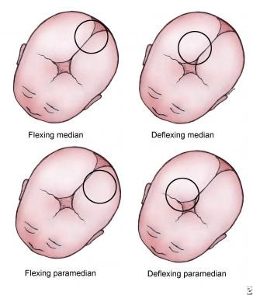
Incorrect sites for cup placement.

This actually increases the work of the extraction by presenting an ever-larger cranial diameter to the birth canal. ^{[21]}

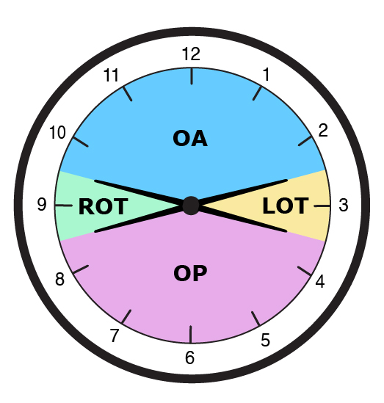
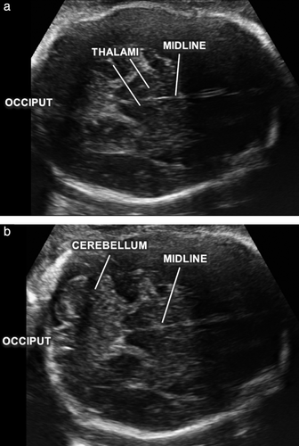

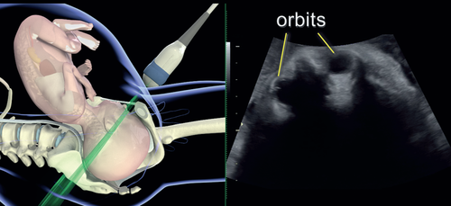

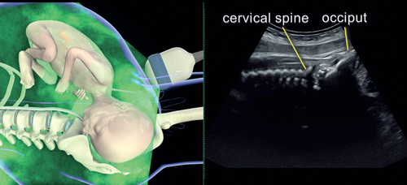

Traction
Once the surgeon has verified cup placement, full vacuum is applied (450-600 mm Hg) and traction follows, paralleling the uterine contractions. The direction of pull on the traction handle changes as the fetal head transverses the pelvic curve (see the images below).
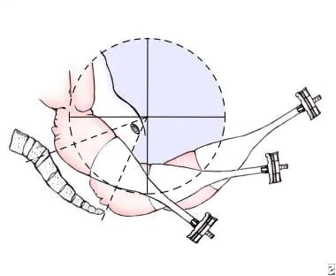

Traction efforts are timed to coincide with uterine contractions. Once the contraction begins, the vacuum pump is actuated until the appropriate degree of vacuum pressure is reached. Traction by the surgeon follows, with the force applied to the extractor handle gradually increased to the desired level, paralleling the rise in uterine force generated by the contraction.
As force is applied maternal expulsive efforts continue. As each contraction wanes, the tension on the extractor handle is relaxed. Attempting traction without the assistance of maternal bearing down efforts and/or a uterine contraction is less effective. These techniques simply predispose to failure and risk a fetal scalp injury from a pop-off.
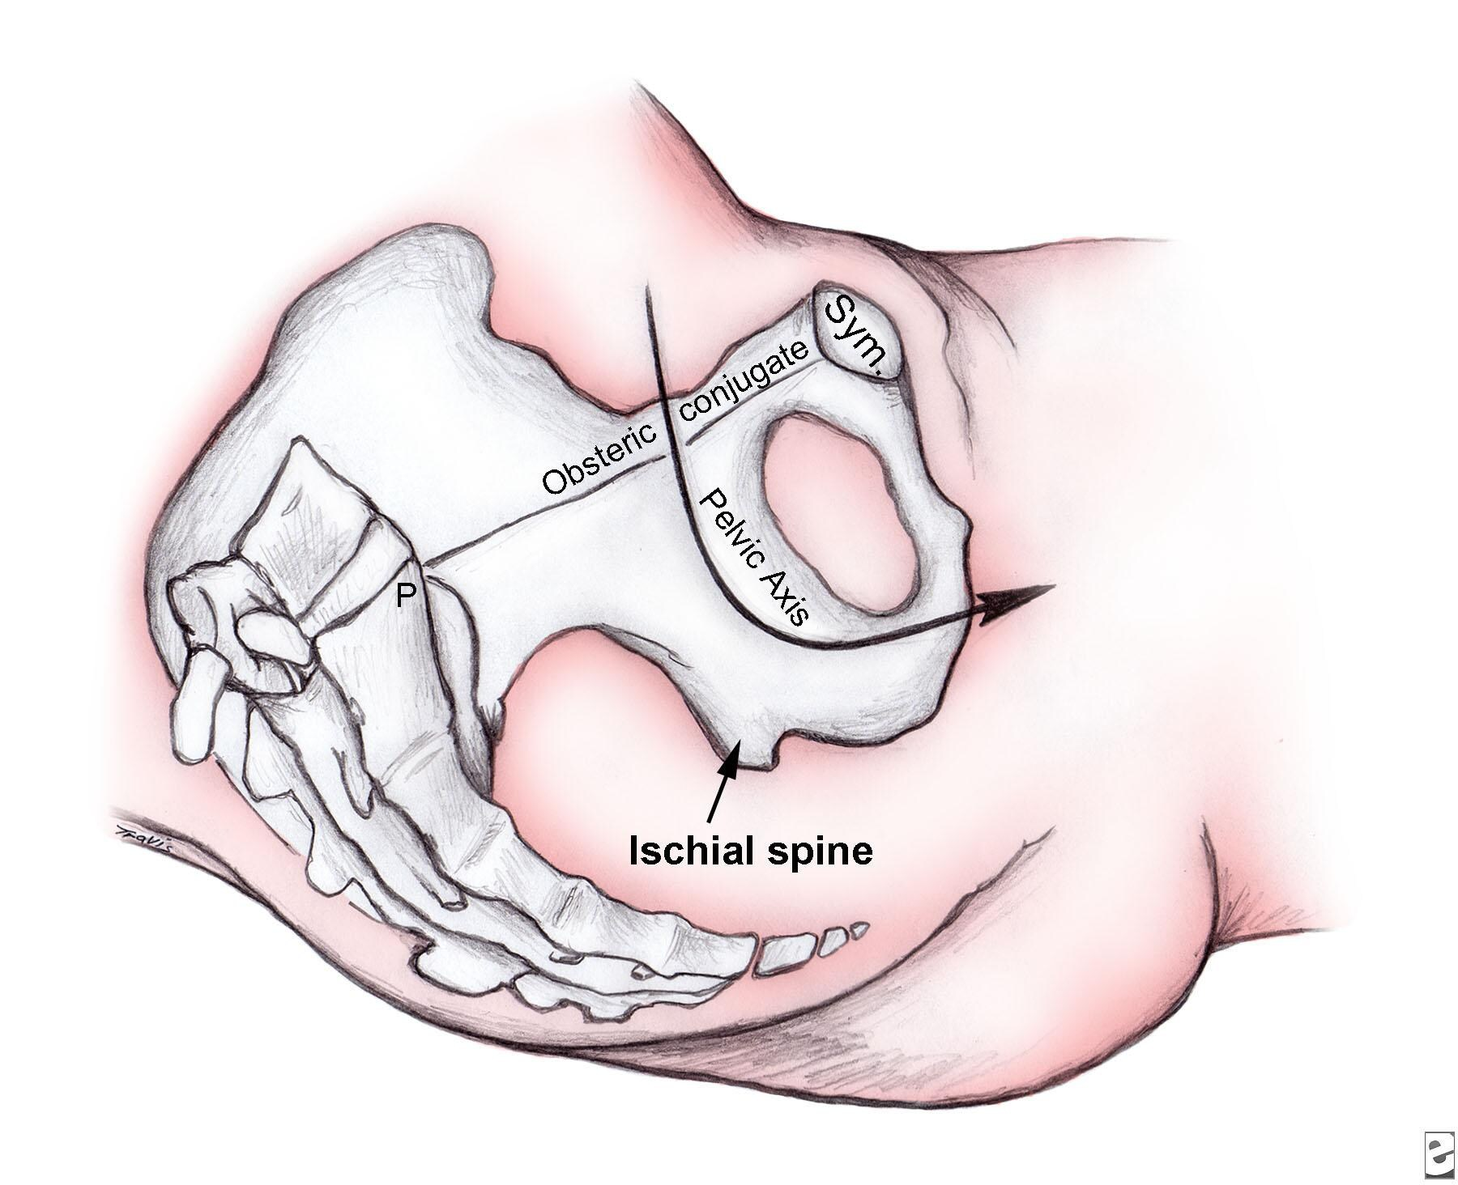
In the relaxation phase between contractions, the vacuum can either be maintained or reduced to less than 200 mm Hg. Both techniques are acceptable. Continuous vacuum throughout the procedure and intermittent vacuum with the vacuum released between contractions, have been studied in a randomized trial. ^{[24]} No differences between groups are noted with regard to the speed of delivery, rates of instrument failure, or maternal or fetal outcomes. Thus, the use of either technique is at the discretion of the surgeon. The authors favor vacuum reduction.

A 2012 Cochrane review examined the safety and efficacy of rapid versus stepwise negative pressure application for vacuum extraction. The authors found that rapid negative pressure application reduces the duration of vacuum extraction without affecting maternal or neonatal outcomes. ^{[25]}
During traction, the surgeon should place the nondominant hand within the vagina, with the thumb on the extractor cup and one or more fingers on the fetal scalp. So positioned, the accoucheur follows the descent of the presenting part and can judge the appropriate and changing angle for traction while gauging the relative position of the cup edge to the scalp. This helps to detect cup separation. The vector of traction is in the curve of the pelvis. The initial angle for traction depends on the station but is usually downward, then progressively extending upward as the head emerges. Once the head has been extracted, the vacuum pressure is relieved, the cup removed and the usual techniques to complete the delivery are followed.

Jerking motions and oblique pulls are best avoided as they risk cup displacement. Any attempt at rotation of the device may lead to detachment or fetal scalp injury. Under traction, the fetal head usually rotates automatically as descent occurs.
An episiotomy is not recommended as a routine measure during a VE operation unless the soft tissue impedes the descent of the presenting part. Episiotomy has been shown to increase the incidence of third- and fourth-degree lacerations.
Ideally, descent of the presenting part should begin with the initial traction effort, assuming proper coordination with the maternal bearing down efforts and the uterine contractions. If the operator is uncertain that descent has occurred, a maximum of 2 additional tractions may be attempted. ^{[26]} The failure to clearly achieve fetal station after properly timed traction in the correct vector of force mandates prompt reassessment of the procedure both in terms of technique and desirability. Recurrent tensioning of the scalp without descent of the presenting part (negative traction) predisposes to cup pop-offs and is believed to increase the risk for scalp injury.

Limits to effort
The maximum duration of a vacuum extraction is unknown. A maximum of 2-3 pop offs, three sets of pulls and/or a total application time of 15-20 minutes have all been recommended, though some argue for lower time limits. ^{[27]}
When the number of pop-offs or the acceptable number of total tractions efforts are considered, the literature is inconsistent. In terms of traction number, studies performed with forceps and rigid-cup extractors have consistent findings. In approximately 85% of births, seemingly independent of whether the delivery is via forceps or the VE, the delivery occurs with 4 or fewer tractions. ^{[28, 29, 30]}
Although several studies have demonstrated a relationship between duration of cup application and development of cephalohematoma, the major morbidity of these lesions was largely cosmetic.

